NAO dancing project

Tony Hasson: 316047281

Loren Terezi: 213633993

Ofek Shemesh: 325753564

Shahar Michel: 315327957

<https://github.com/tonyhasson/Robotics_Project>

Summary:

The project is about using the NAO robot's vision recognition capabilities in the programming software Choregraphe to recognize numbers from 1 to 5. Each number corresponds to a different dance routine for the robot to perform.

More information:

Dance #1 -> Macarena

Dance #2 -> 80’s dance

Dance #3 -> The nutcracker

Dance #4 -> Wednesday Tiktok dance

Dance #5 -> Robot dance

It also recognized the symbol ‘X’, which tells him to sit down.

How to use:

Step 0: Download the zip file from the GitHub repository. The project can be found in the "NAO" folder within the repository.

Step 1: To access the project, open the Choregraphe application. Then, click on "FILE" and select "OPEN PROJECT." Locate the project you downloaded, and open it.

Step 2: Run the project on Choregraphe. The robot will stand up and say, "Hello, my name is Lost. I am named after my creators, Loren, Ofek, Shahar, and Tony. If you would like me to dance, please show me a number from 1 to 5."

Step 3: The user will show the robot a number from 1 to 5 using the upper camera. The robot will then perform the corresponding dance routine.

Step 4: Once the robot finishes its dance routine, it will say, "Thank you for watching me dance. If you would like to see me dance again, please show me another number” . Or, you can show the robot the mark 'X' to make it say 'Goodbye, give my creators an A plus please.' It will then sit down and end the process.

Architechture:

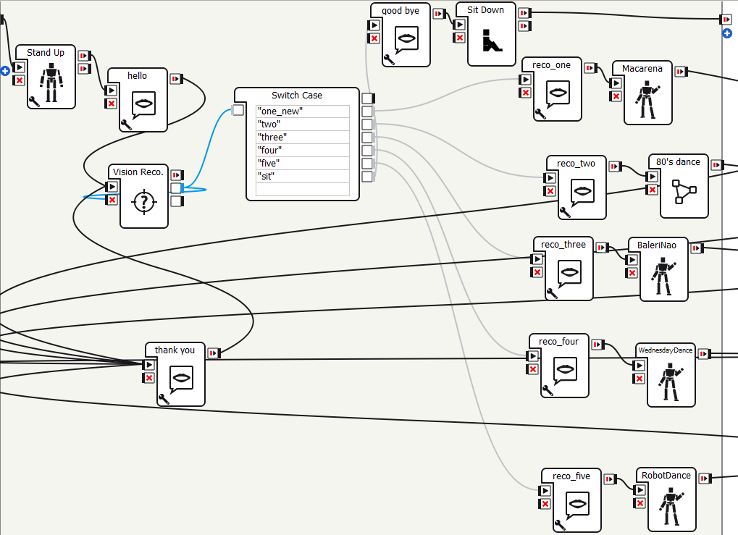

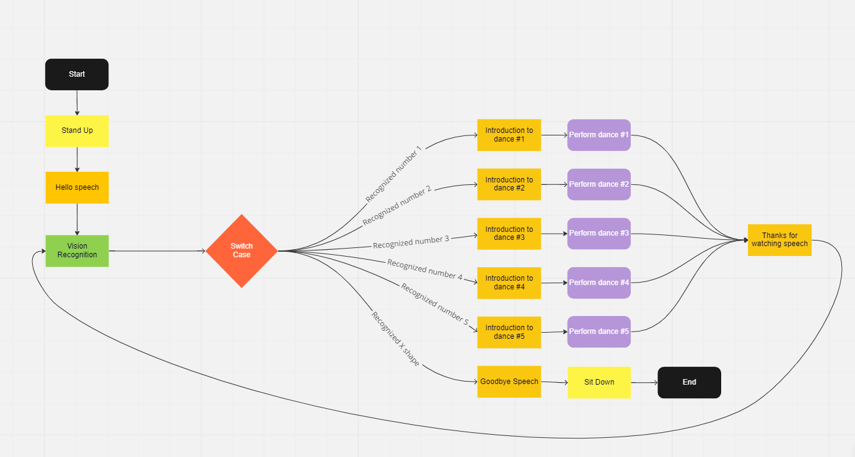

Our Process:

The project goal was initially to make the robot dance, but to make it more interesting and challenging we decided to add the vision recognition feature to it. The project took around a month+ to complete. Throughout the process, we learned a lot about how to use the NAO robot and the Choregraphe application. We also gained experience in building dances using the Timeline method and implementing vision recognition in the Choregraphe application.

